Complete 3 tasks, related to training 4:

1. Create test 1, which goes to RMSsys login page, login with correct credentials (Username – EugenBorisik, Password – qwerty12345, URL - <https://192.168.100.26/> ; use Maven as project and build management tool; TestNG as testing framework).
2. Create By variables, which covers all possible types of location in Selenium WebDriver.
3. Locate css and xpath selectors for following elements in RMSys (2 variants – css and xpath – for each, do NOT add them to project, just create word document with these locators):

**Login page:**

1. Username input
2. Password input
3. Remember me label
4. Remember me input
5. Login button

**Home page:**

1. Sign out link
2. Selector, which grabs all links to offices (see screenshot 1)
3. Link to Chapaeva 118 office
4. Link to Lunch Voting

**Vacation page -> Create Vacation tab:**

1. Information span for Notification To
2. Information span for Notification CC

**Company page:**

1. Selector, which grabs all containers for companies (see screenshot 2)
2. Selector for Contact tab, which will be suited for all companies (see screenshot 3 and 4)

**Screenshot 1 (for ‘g’):**

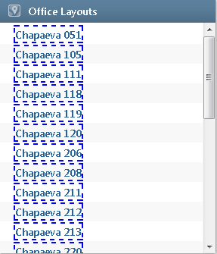

**Screenshot 2 (for ‘l’):**

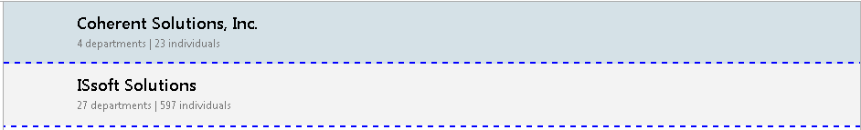

**Screenshot 3 (for ‘m’):**

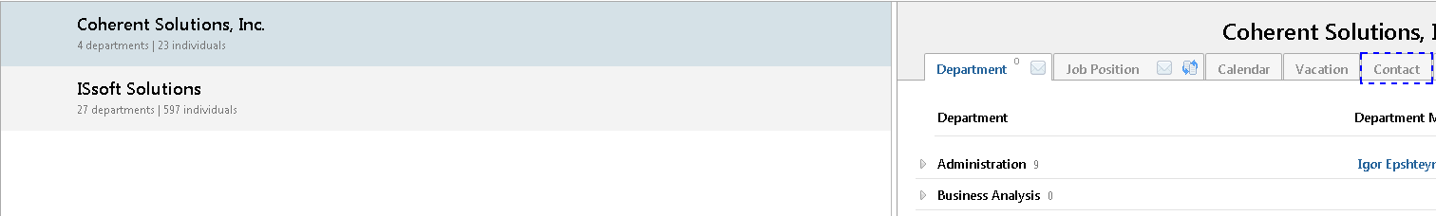

**Screenshot 4 (for ‘m’):**

